Programs today targeting older adults too often rely upon outdated models, paradigms that do not reflect current cultural trends, or an incomplete understanding of the deeper issues faced by persons in the later stages of life. Today’s research shows that what is often lacking in older adult programming is an emphasis on the spirituality of aging.

This certificate program will seek to enable participants to gain an understanding of the essential role of spirituality and how spirituality enhances the efficacy of other health care and congregational services to and with older adults. This certificate program will focus on developing an awareness of spirituality in aging, allowing participants to engage the spirituality of the older adults whom they serve as well as their own spirituality in a manner that is wholistic and sensitive to spiritual formation and human development.
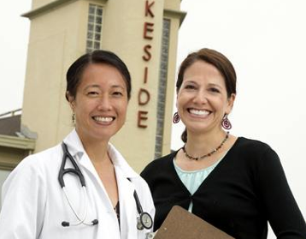

The Program includes a half-day retreat and four half-day classes held on Saturdays. The orientation retreat will be held on Saturday, September 17, 2016.

The classes will be held the third Saturdays:
- Oct. 15 Aging Defined
- Nov. 19 Spirituality & Aging,
- Jan. 21, 2017 Culture, Spirituality & Aging,
- Feb. 25 Practical Approaches to Address Aging,
The Certificate program provides continuing education credit for those seeking hours for:
- BRN
- BBS
- RCFE
- NAB
- Denominational Continuing Education requirements

Come to a Discovery meeting to learn more! For information about the Certificate on Spirituality & Aging contact:
- Phone: 626.765.9500
- Email: info@ntswest.org
- Website: www.ntswest.org
Co-Sponsors
We are people who are excited to be part of a new way of doing seminary – serving and building up faith communities by offering a new theological education resource in Southern California. The New Theological Seminary of the West offers graduate courses, lay leader education, continuing education for faith leaders, members, clergy, programming for churches, and independent study options.

See more at: www.ntswest.org

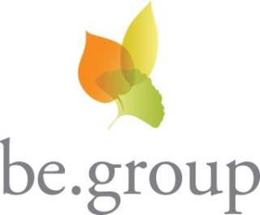
At be.group, we strive to be more than just a provider of senior living communities. We are on a mission to help older adults reach their full potential. As a local nonprofit organization, we are committed to the notion that better physical environments, better service and better lifestyles lead to the rich, purposeful life everyone desires and deserves.

See more at: www.thebegroup.org
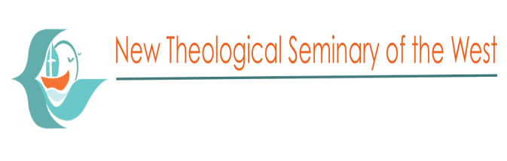
2016 Certificate on Spirituality &
Aging

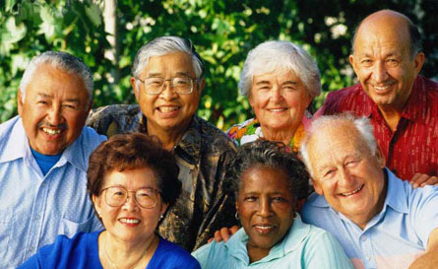

A Course of integration of faith & practice
for those working with & caring for the older members of our community

